**CAMPING ESSENTIALS**

**Table of Contents**

**Introduction**

Background --------------------------------------------- 1

**Screenshots of Output**

Login ----------------------------------------------------- 1

Signup --------------------------------------------------- 2

Dashboard ---------------------------------------------- 2

Logout --------------------------------------------------- 3

Homepage ---------------------------------------------- 3

Sorting --------------------------------------------------- 4

Searching ----------------------------------------------- 4

**Code Snippets**

Login ------------------------------------------------------ 5

Signup ---------------------------------------------------- 6

Dashboard ---------------------------------------------- 7

**References** ------------------------------------------------- 8

**Developer’s** ------------------------------------------------- 9

**INTRODUCTION**

**SCREENSHOTS OF OUTPUTS**

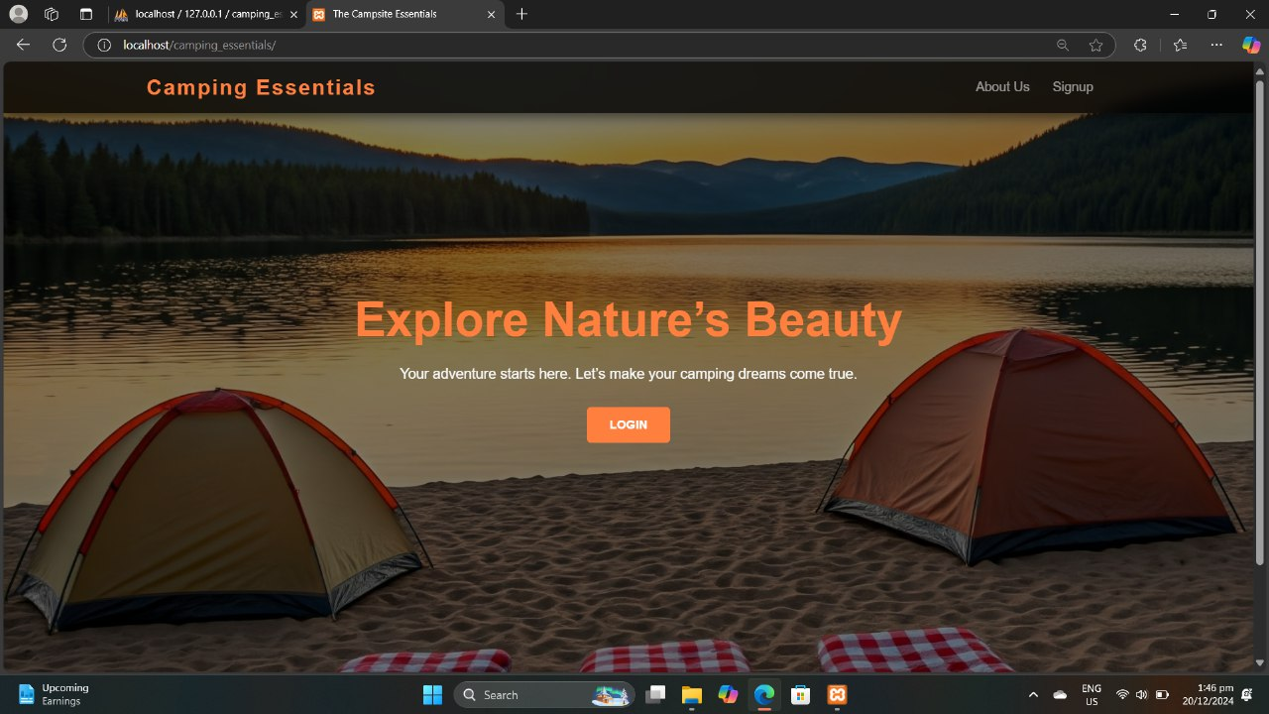Landing Page:

Sign Up:

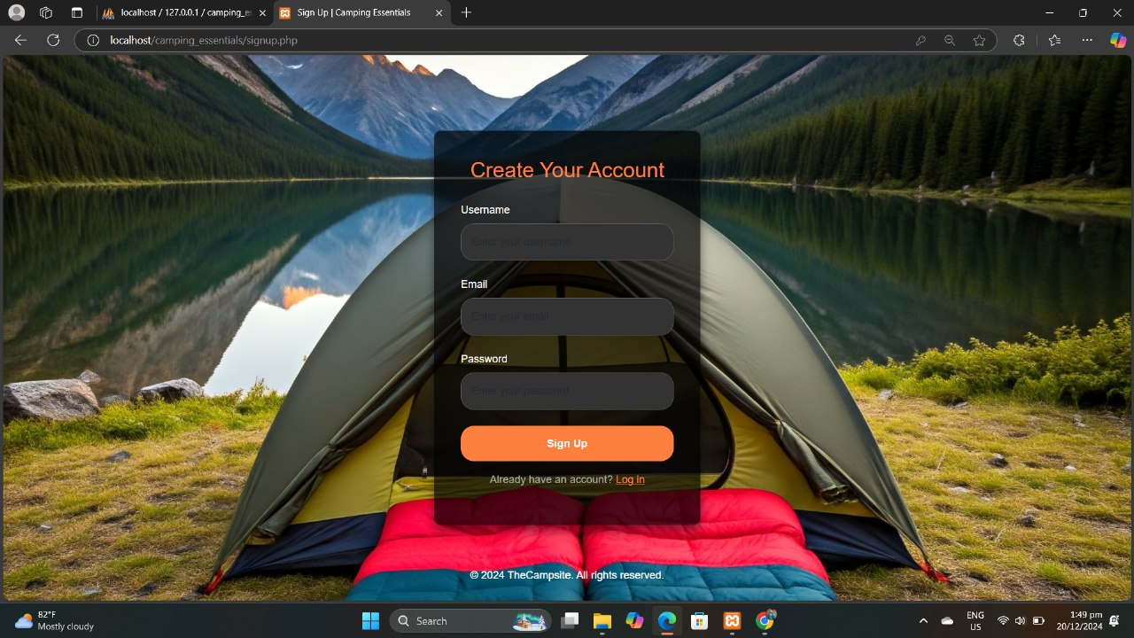

Dashboard:

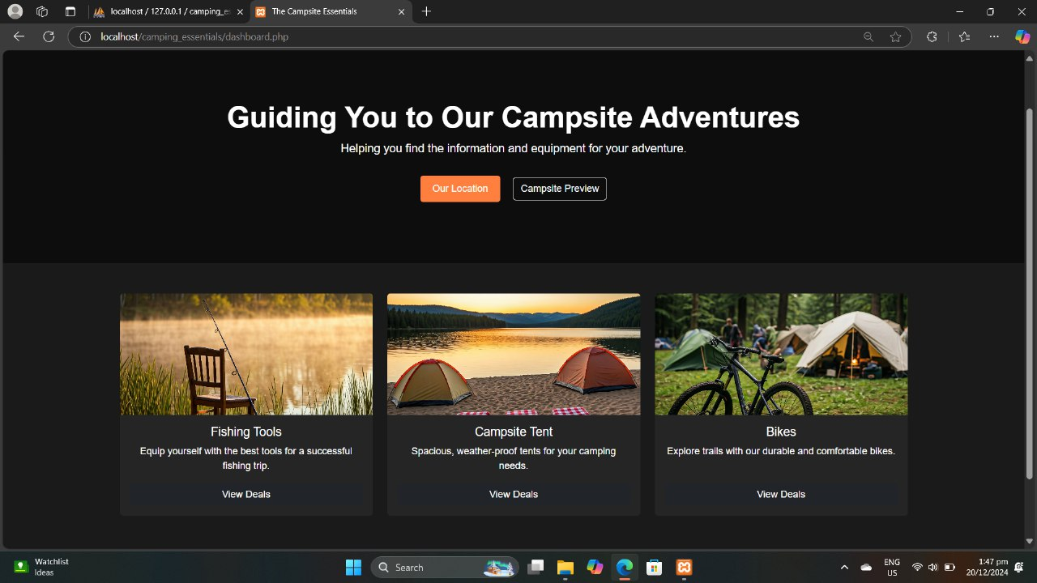

Login: 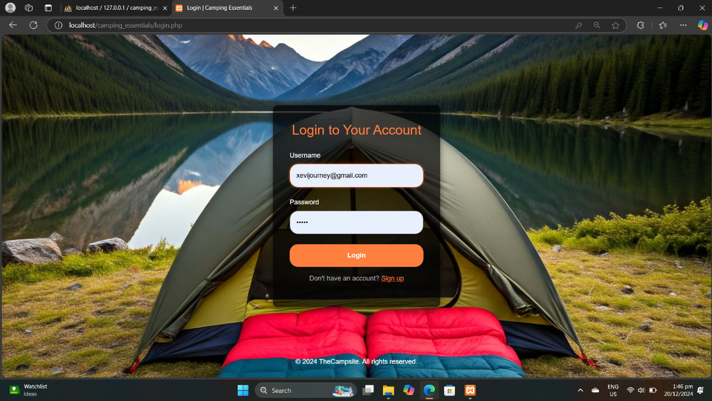

Dashboard: 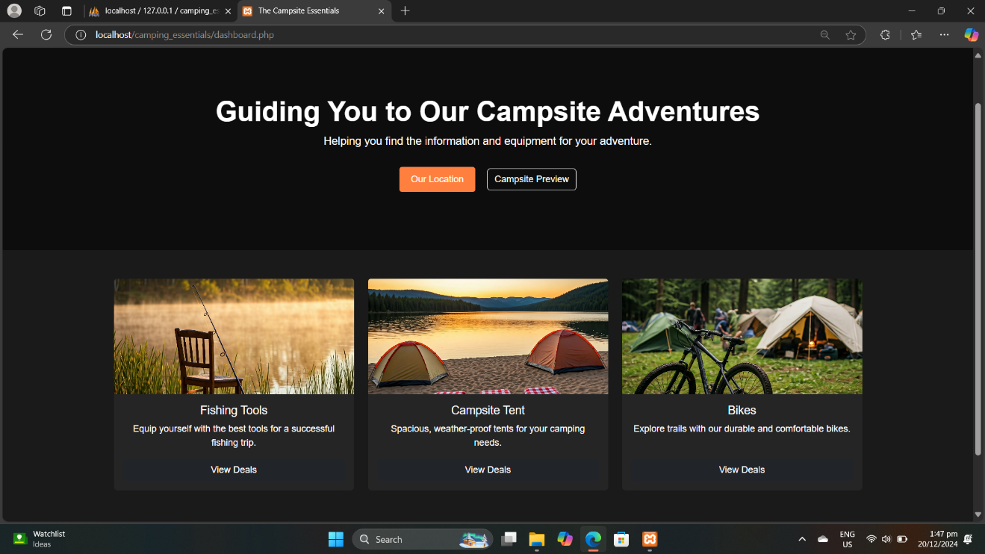

Tent Deals w/ Searching and Sorting Algorithm: 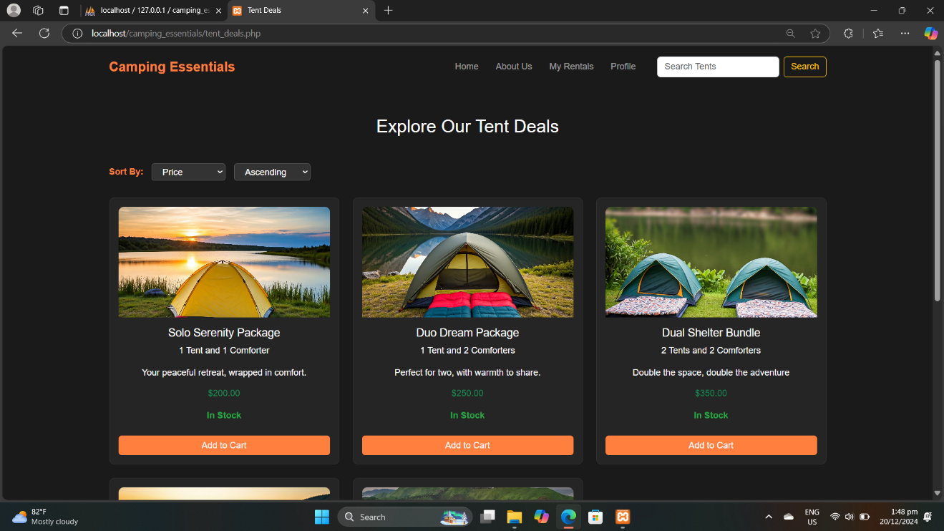

Bike Deals w/ Searching and Sorting Algorithm: 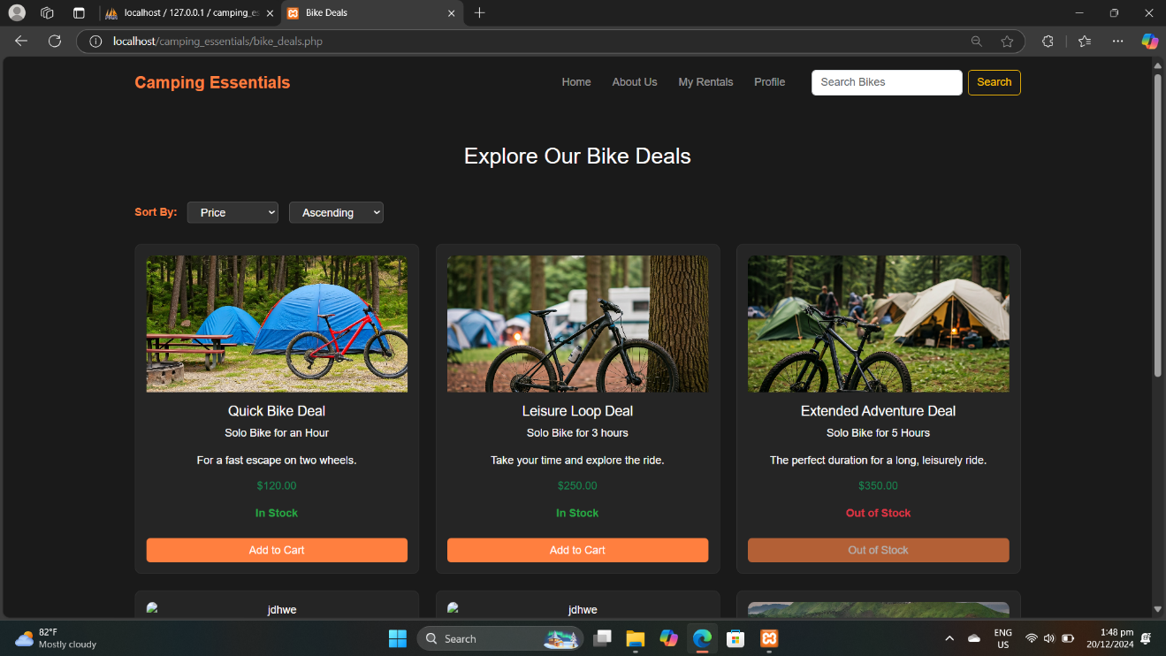

Fishing Tools Deals w/ Searching and Sorting Algorithm: 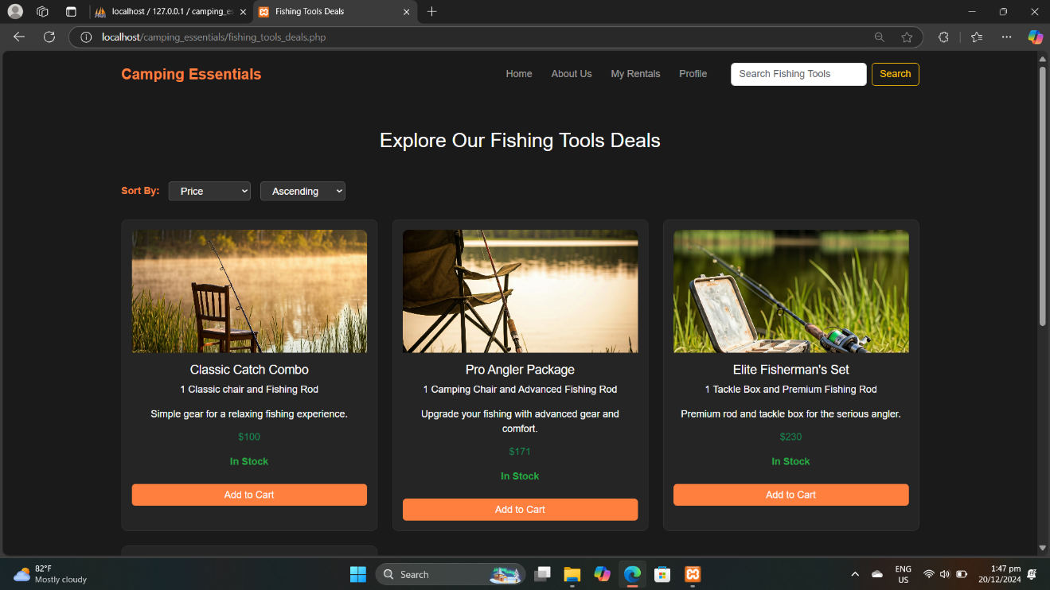

**CODE SNIPPETS**

Log in: 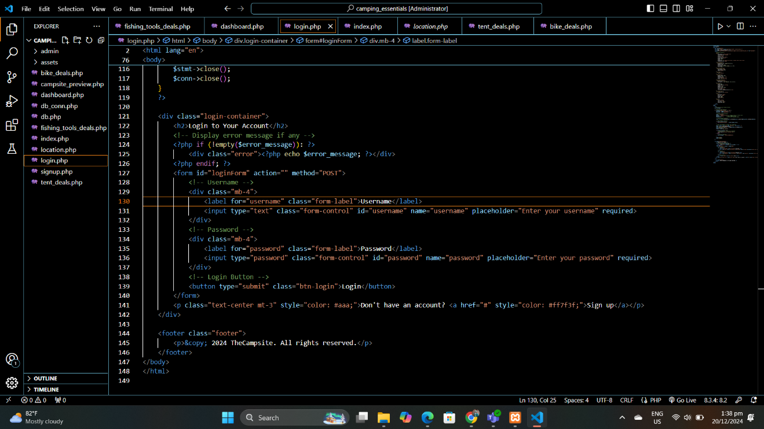

Sign up: 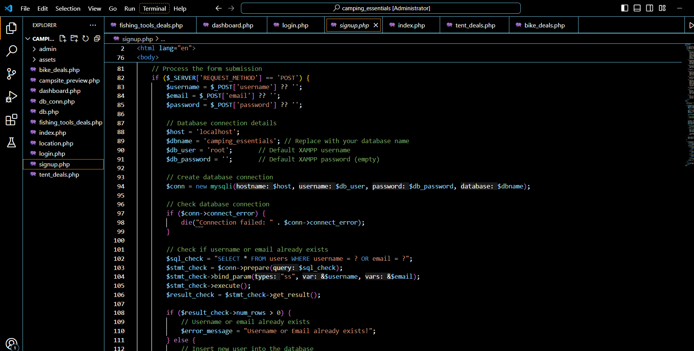

Dashboard: 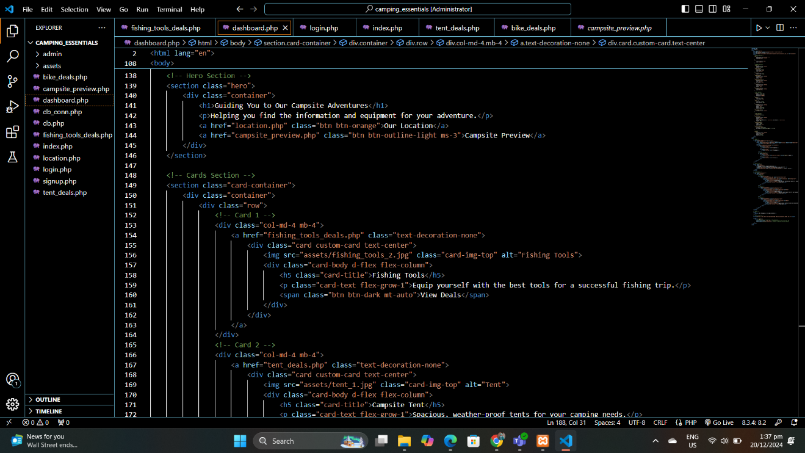

**REFERENCES:**

[**https://dribbble.com/shots/19180659-CabinCo-Camping-Company-Portfolio-Website**](https://dribbble.com/shots/19180659-CabinCo-Camping-Company-Portfolio-Website)

[**https://chatgpt.com/**](https://chatgpt.com/)

[**https://gemini.google.com/app/51181e6f239114ad**](https://gemini.google.com/app/51181e6f239114ad)

[**https://getbootstrap.com/**](https://getbootstrap.com/)

[**https://leafletjs.com/**](https://leafletjs.com/)

[**https://www.google.com/**](https://www.google.com/)

**DEVELOPER’S PROFILE**

**Name:** Vincent L. Bernales

**Educational Background:**

**- Tertiary**

Bohol Island State University-Candijay Campus

Purok 1, Cogtong, Candijay, Bohol

2022-present

**- Secondary**

Biabas Trade High School

Ubay, Bohol

2021-2022

**- Elementary**

Paraiso Elementary School

Mabini, Bohol

2015-2016

**Role in the Project:** Programmer

**Contact Information:** [vincent.bernales@bisu.edu.ph](mailto:vincent.bernales@bisu.edu.ph)

**Name:** Lea mae Madrio

**Educational Background:**

**- Tertiary**

Bohol Island State University-Candijay Campus

Purok 1, Cogtong, Candijay, Bohol

2022-present

**- Secondary**

Guinacot National High School

Guinacot, Guindulman, Bohol

2019-2020

**- Elementary**

Guindulman Central Elementary School

Guindulman, Bohol

2014-2015

**Role in the Project:** Researcher

**Contact Information:** [leamae.madrio@bisu.edu.ph](mailto:leamae.madrio@bisu.edu.ph)

**Name:** Jhimea Magbanua

**Educational Background:**

**- Tertiary**

Bohol Island State University-Candijay Campus

Purok 1, Cogtong, Candijay, Bohol

2022-present

**- Secondary**

Cogtong National High School

Cogtong, Candijay, Bohol

2021-2022

**- Elementary**

Sta. Ana Elementary School

M. Roxas St. Sta. Ana, Manila

2015-2016

**Role in the Project:** Researcher

**Contact Information:** [jhimea.magbanua@bisu.edu.ph](mailto:jhimea.magbanua@bisu.edu.ph)

**Name:** Lindy Mandawe

**Educational Background:**

**- Tertiary**

Bohol Island State University-Candijay Campus

Purok 1, Cogtong, Candijay, Bohol

2022-present

**- Secondary**

Candabong National High School

candabong, Anda, Bohol

2021-2022

**- Elementary**

Candabong Elementary School

Candabong, Anda, Bohol

2015-2016

**Role in the Project:** Reseacher

**Contact Information:** [lindy.mandawe@bisu.edu.ph](mailto:lindy.mandawe@bisu.edu.ph)

**Name:** Jason Rey Moralde

**Educational Background:**

**- Tertiary**

Bohol Island State University-Candijay Campus

Purok 1, Cogtong, Candijay, Bohol

2022-present

**- Secondary**

Candijay National High School

Candijay, Bohol

2019-2020

**- Elementary**

Guio-ang Elementary School

Guio-ang, Guindulman, Bohol

2013-2014

**Role in the Project:** UI Designer

**Contact Information:** [jasonrey.moralde@bisu.edu.ph](mailto:jasonrey.moralde@bisu.edu.ph)